C:\STOCKLAYOUTS\CURRENT PROJECTS\FN99801-PL\FN99801-IMG08.emfC:\STOCKLAYOUTS\CURRENT PROJECTS\FN99801-PL\FN99801-IMG04.emfC:\STOCKLAYOUTS\CURRENT PROJECTS\FN99801-PL\FN99801-IMG04.emf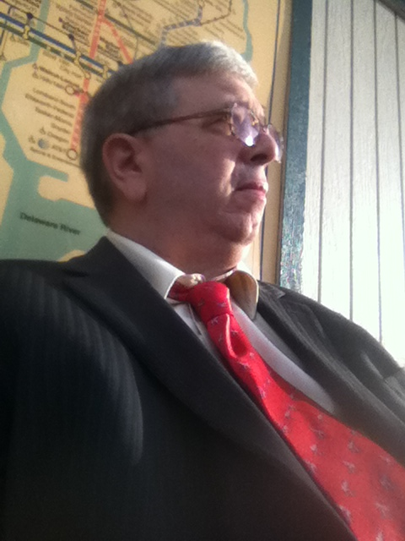C:\STOCKLAYOUTS\CURRENT PROJECTS\FN99801-PL\FN99801-IMG05.emfC:\STOCKLAYOUTS\CURRENT PROJECTS\FN99801-PL\FN99801-IMG06.emfC:\STOCKLAYOUTS\CURRENT PROJECTS\FN99801-PL\FN99801-IMG07.emfC:\STOCKLAYOUTS\CURRENT PROJECTS\FN99801-PL\FN99801-IMG04.emfC:\STOCKLAYOUTS\CURRENT PROJECTS\FN9980102D\FN9980102D-PL\FN99801-IMG03.EPS

Who else are you going to call to meet your needs at 7 PM at night?

If you need a loan signing, healthcare directive, power of attorney, or other documents requiring your notarized signature, I am available to meet your needs in your home, your office, or a mutually selected venue.

**Call For Services Today**

Loan Signing Consultation

* **View Background Information**
* **Title Abstractor**
* **Professional Quality**
* **Timely Performance**

Affordable Trial Paralegal

3104 Penn Valley Av

Bristol, PA 19007 USA

(215) 718-4061 Cell

(877) 203-8005 Toll free

(215) 358-8072 Fax

URL:

http://bucksmobilenotary.weebly.com/

Legal Services as Independent Paralegal & Notary

Closings On Schedule

Mobile Notary & Paralegal Services

**Loan Closing Chart Projections**

**2013 Jun Dec 2014 2015 55**

**300**

**200**

**100**

* I am not an attorney and I am not licensed to give legal advice or accept fees for legal advice.

 Profound interest in the Law

 Analytical Skills

 Attention to Detail

 Excellent Communication Skills

 Excellent Computer Skills

Great Writing Skills

Paralegal Consultation

 Trusts

 Loan Signings

 Adoptions

Critical understanding of documents and their use are often required in contract compliance, negotiations, and insurance placement..

Skills also require good cooperation and interpersonal working relationships.

My background includes computer programming and as an entrepreneur I developed databases that provided necessary tools to a Fortune 500 company that enabled it to track sales and legal compliance issues across the entire country.

**Knowledge and eDiscovery**

As a paralegal with intimate knowledge of Concordance, iBlaze (Summation), Relativity, InControl, iConnect and other relational databases, I can provide the necessary skills required to handle all your eDiscovery requests and research..

Paralegals are also required to have a strong ethical sense. I have attended ethical training sessions and continuing education courses to ensure ethical compliance.

**Leadership Skills**

Experienced in adverse document reviews and being in charge of teams of paralegals has provided me with the background and resources required to make effective decisions.

When notaries or paralegals act as a mediator, their role is to reduce tensions, give each party an opportunity to speak, and encourage parties to reach a compromise.

**Realizing Your Case**

A good paralegal also has excellent writing skills. The use of correct grammar and punctuation are critical skills.

If you’re an attorney and want your case presented at trial, what better than to hire a paralegal with trial experience and who is certified as a Trial Director Certified Trainer?

 Closings On Time

 Quality Services

 Community Based

Comprehensive Notary & Paralegal Consulting* Services

The notary and paralegal is not only needed to help one party but ensures that everyone understands their rights. When a couple goes before a notary, the notary has a duty and obligation to be fair to both parties.